Network Task
1.Get me the IP address of a particular domain (guvi.in). How do I find my CPU/memory usage of my server?. Test the connectivity between 2 nodes?
===========================================================
a.Get me the IP address of a particular domain (guvi.in)
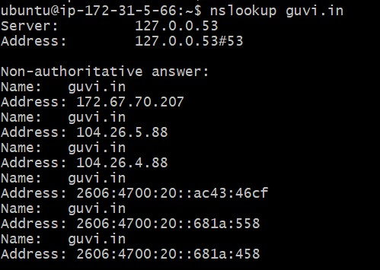
B. CPU usage

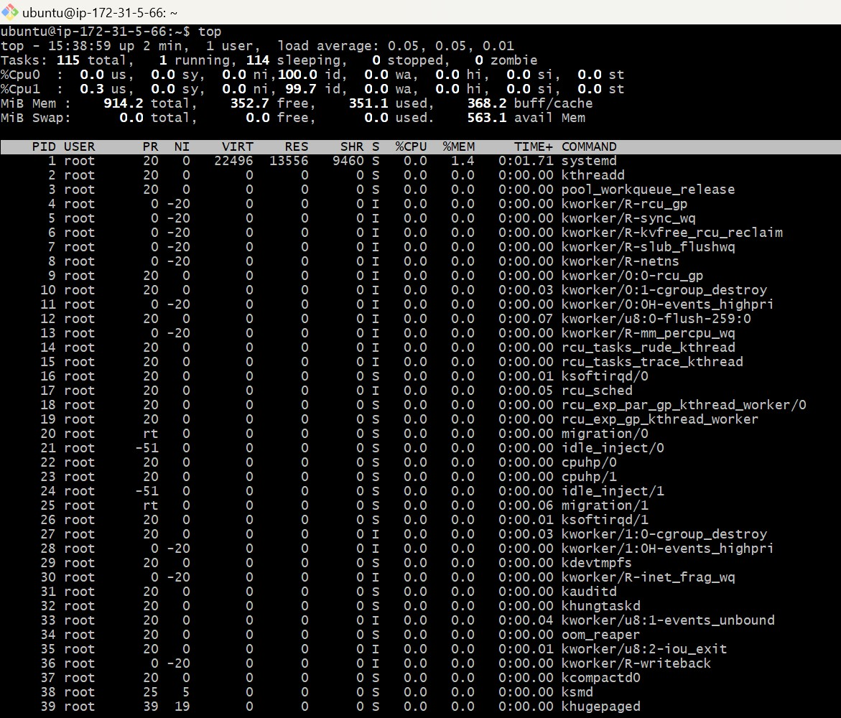
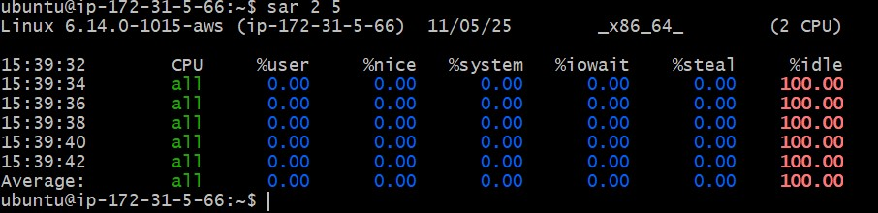

C. Memory Usage:
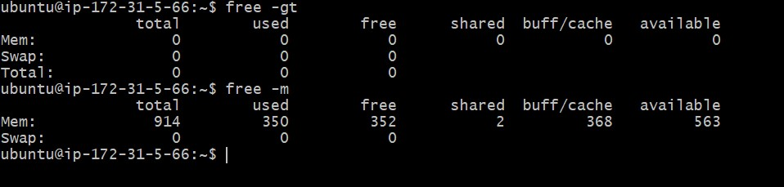

D. Test connectivity
host1
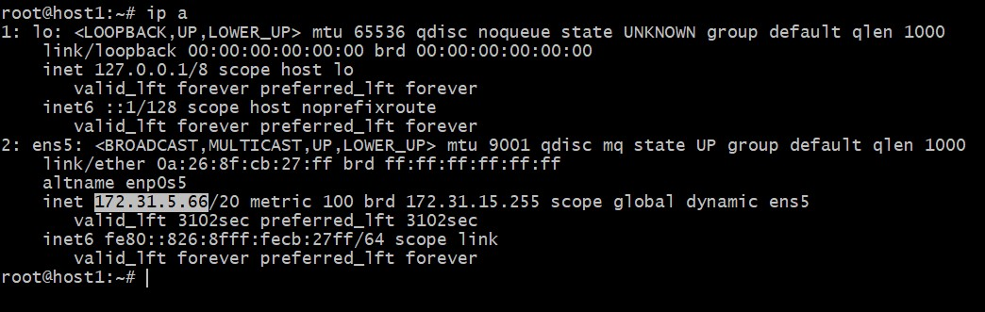
Host2
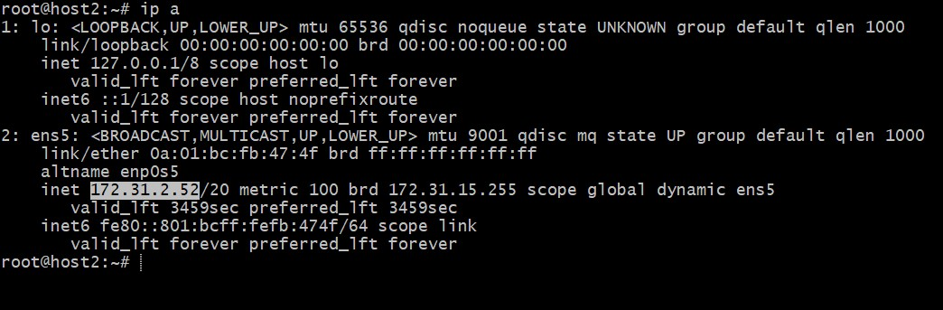
Connectivity
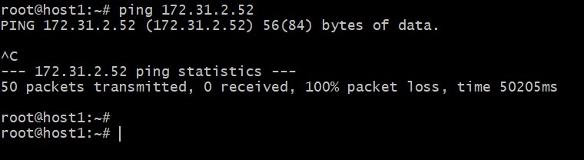

2.I have deployed an application in guvi.com:9000, and logs show my app is running, but I’m unable to view the page. Check whether my port is open or not ?



